USER INTERFACE AND USER EXPERIENCE DESIGN LAB

NAME : HARITHA SREE S T
REG NO: 23MIS0008
SLOT: L55+L56
COURSE CODE: ISWE407P

EXPERIMENT -1

Bad Design 1: Food Court Menu Board
Description:
A university food court menu board displaying numerous food items across multiple counters. The menu contains a large amount of text with small fonts, making it difficult for customers to quickly locate their desired items.
Source of Photograph:
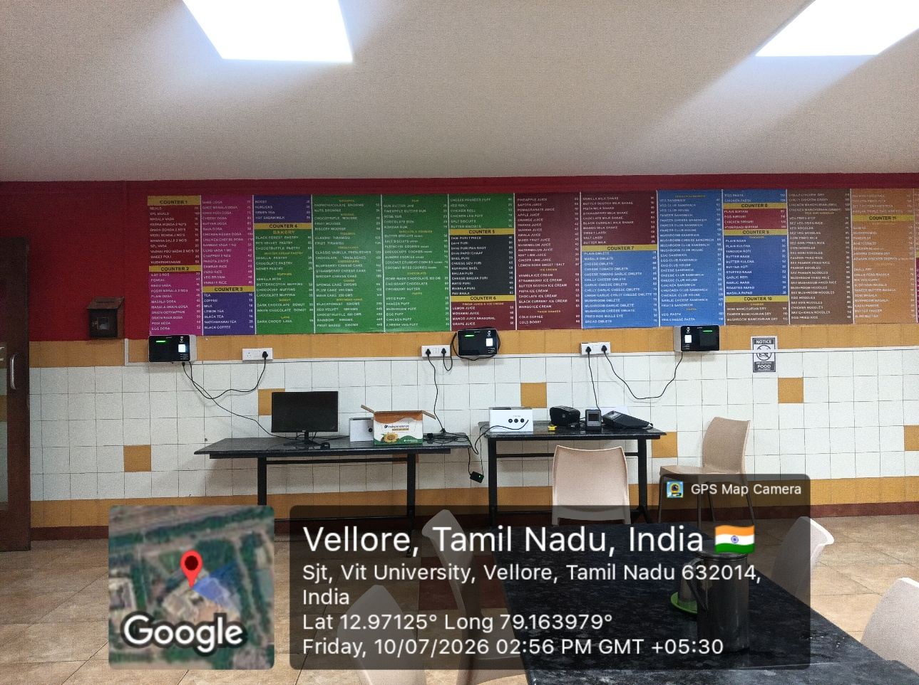

Place:
Food Court (ARASAN), VIT University, Vellore
Reasons why the design is bad:
- Too much information is displayed on a single board.
- Small font size reduces readability.
- Customers need more time to find menu items.
- Exposed wires below the menu board create visual clutter.
- No clear queue or ordering guidance is provided.
Suggested Improvement:
- Use digital menu displays.
- Increase font size and improve spacing.
- Organize menu items into clear categories.
- Conceal exposed cables.
- Add queue guidance and directional signs.
Bad Design 2: Service Elevator Signage
Description:
A service elevator with a temporary paper notice indicating the accessible floors. The signage is not prominent and may confuse users.
Source of Photograph:
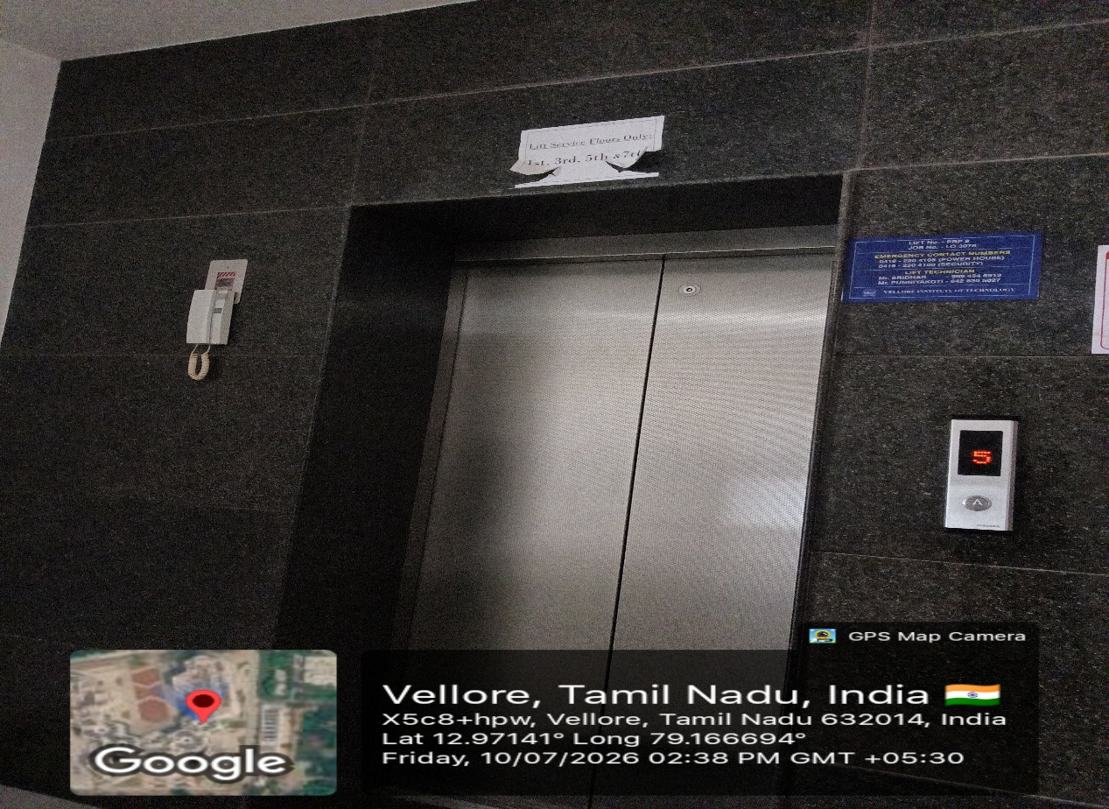
Place:
PRP Building,VIT University, Vellore.
Reasons why the design is bad:
- Temporary paper sign looks unprofessional.
- Information is difficult to read from a distance.
- Poor visibility of service floor details.
- Lack of proper wayfinding signs.
- Overall appearance is not user-friendly.
Suggested Improvement:
- Install permanent signboards.
- Use larger fonts with better contrast.
- Improve lighting around the elevator.
- Include directional signs for easy navigation.
Bad Design 3: Parking Area
Description:
A parking area where motorcycles and bicycles are parked together without proper markings or designated parking spaces.
Source of Photograph: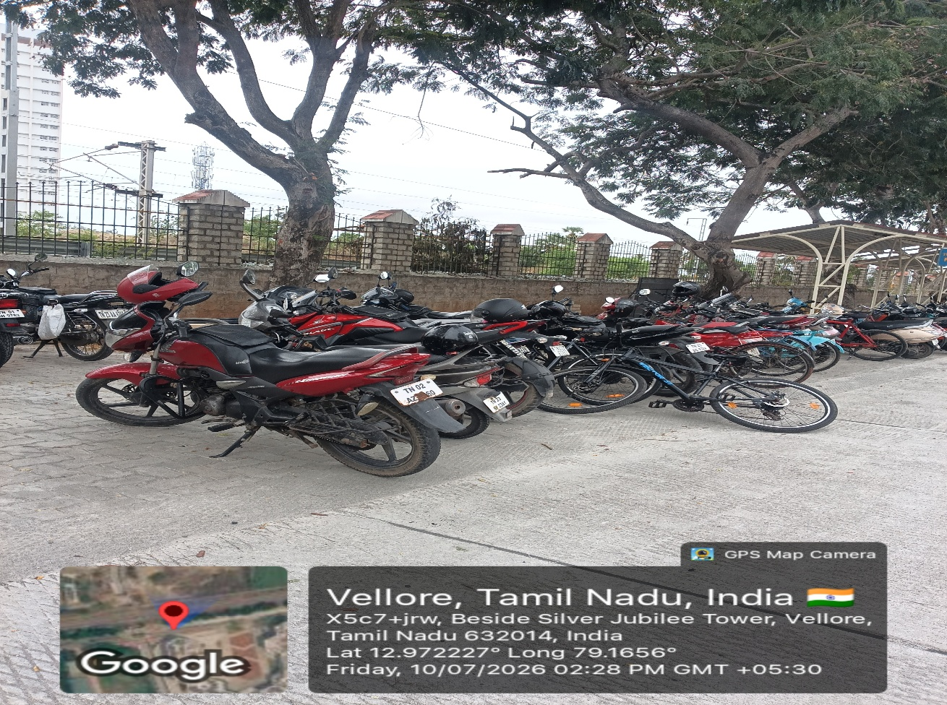
Place:
Beside Silver Jubilee Tower, VIT University, Vellore
Reasons why the design is bad:
- Parking spaces are not clearly marked.
- Vehicles are parked in an unorganized manner.
- No separate area for bicycles and motorcycles.
- Lack of directional signage.
- Difficult to maintain orderly parking.

Suggested Improvement:
- Paint clear parking slot markings.
- Separate bicycle and motorcycle parking zones.
- Install parking direction boards.
- Add parking regulations signage.
- Improve overall organization of the parking area.
Bad Design 4: Open Drainage Area
Description:
An exposed drainage chamber with visible pipelines and water accumulation near a pedestrian pathway.
Source of Photograph:
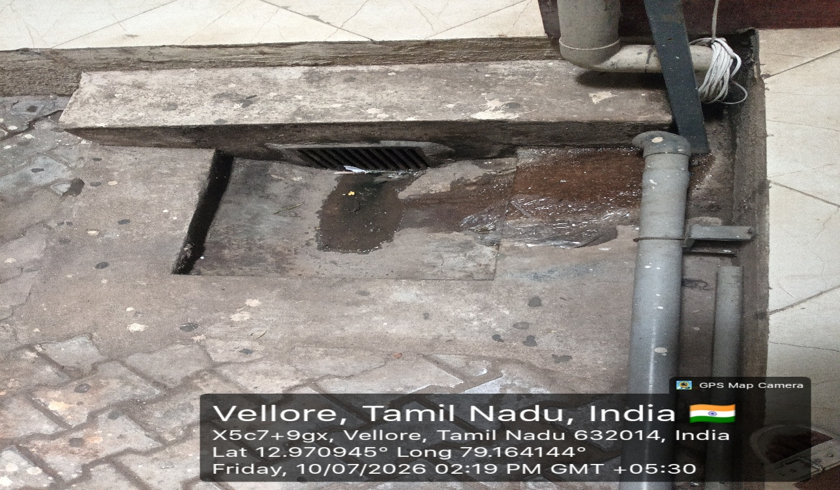

Place:
VIT University, Vellore
Reasons why the design is bad:
- Exposed drain creates a safety hazard.
- Water stagnation affects hygiene.
- Poor maintenance reduces visual appeal.
- Open drainage can produce unpleasant odours.
- Surrounding area appears untidy.
Suggested Improvement:
- Install a secure drain cover.
- Improve drainage to prevent water stagnation.
- Clean and maintain the area regularly.
- Cover exposed pipelines where possible.
- Improve the surrounding pavement and cleanliness.
Bad Design 5: Exposed False Ceiling
Description:
A corridor with missing false ceiling panels, exposing HVAC ducts, electrical wiring, and other building services.
Source of Photograph:
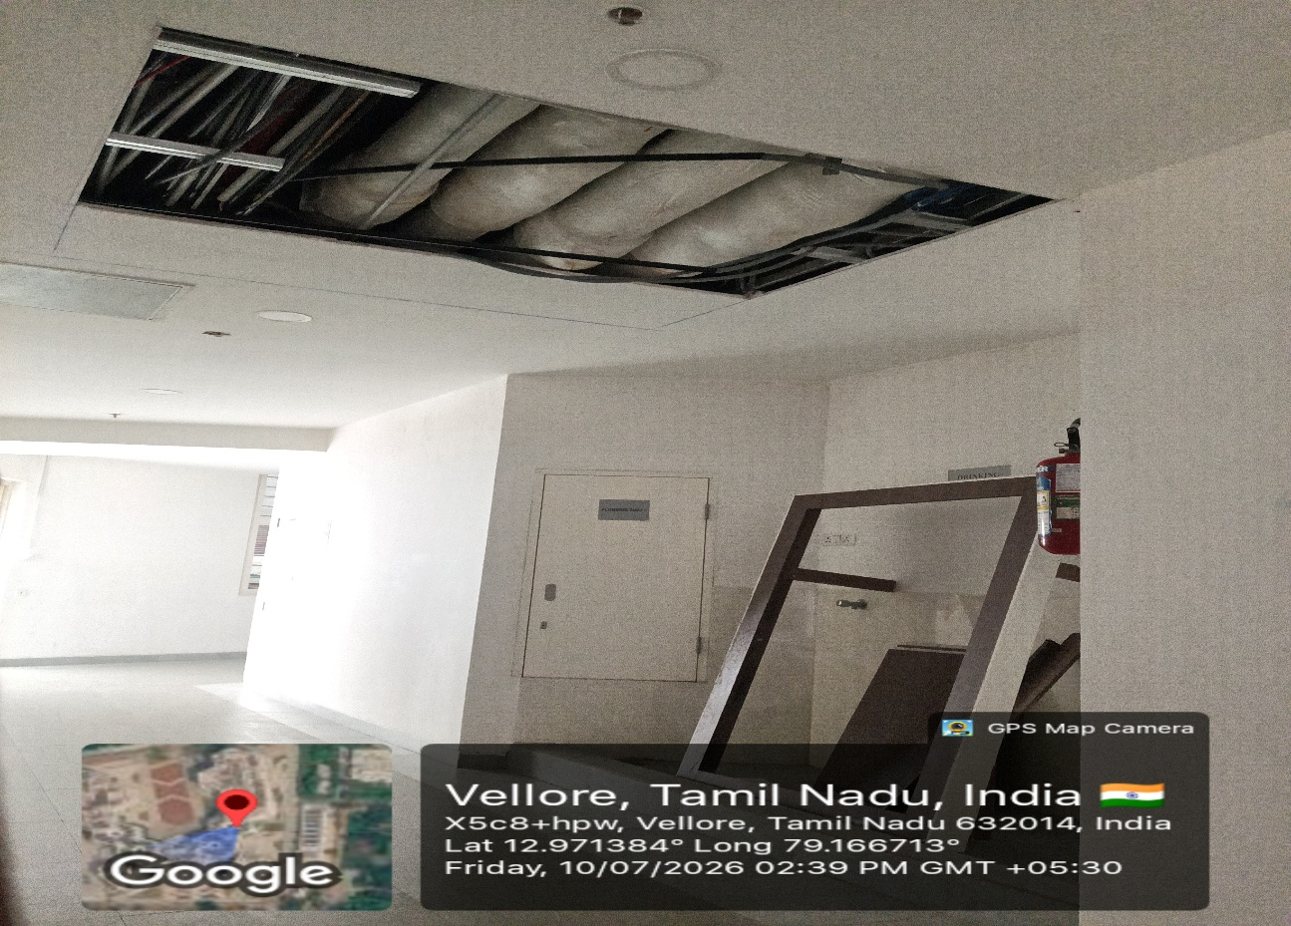
Place:
PRP Building,VIT University, Vellore
Reasons why the design is bad:
- Exposed ducts and wiring reduce aesthetics.
- Ceiling appears unfinished.
- Dust can accumulate on exposed utilities.
- May raise safety and maintenance concerns.
- Creates a poor first impression of the building.
Suggested Improvement:
- Replace the missing ceiling panels.
- Conceal ducts and electrical wiring.
- Perform regular maintenance inspections.
- Repair damaged ceiling sections promptly.
- Maintain a clean and finished corridor appearance.

